Exercise 4: MQTT Publish/Subscribe
Week: 4 (Hands-On Laboratory Exercise)
Objective: To deploy an enterprise-grade MQTT broker (EMQX) locally via Docker, configure Node-RED as an automated MQTT publishing client, utilize Postman as an MQTT subscribing client, and explore topic hierarchies using wildcards.
Step 1: Initialize the EMQX MQTT Broker via Docker
1. Open Docker Desktop: Ensure the Docker daemon is running in the background.
2. Launch via Docker Desktop: Open your computer's Docker Desktop click the run button for the EMQX image, and use the settings as follow:
○ Ports: 18083, 1883, 8083, 8080, 8883
○ Volumes: ■ /opt/emqx/data: This is the most critical folder. It contains the Mnesia database, which stores:
■ /opt/emqx/log: Highly recommended. This folder stores all operational logs, which are essential for troubleshooting.
3. Verify the Broker: Open your web browser and navigate to http://localhost:18083. Log in with the default credentials (admin / public) to verify the broker is active.

Step 2: Configure Node-RED as an MQTT Publisher
Now that the broker is listening, we will configure Node-RED to act as an IoT edge device (Client), periodically publishing simulated telemetry data.
1. Add an Inject Node: Drag an inject node onto your Node-RED workspace. Double-click it:
○ Payload: Change to JSON and enter: {"temperature": 25.5, "sensor": "ESP32_01"}
○ Repeat: Set to interval every 5 seconds.
2. Add an MQTT Out Node: Drag an mqtt out node onto the workspace and wire it to the inject node. Double-click it:
○ Server: Click the pencil icon to add a new MQTT broker. Set the Server to host.docker.internal and Port to 1883. Click Add.
○ Topic: Type campus/lab1/temperature.
3. Deploy: Click Deploy. Your Node-RED client is now silently publishing a payload to the broker every 5 seconds.

Step 3: Configure Postman as an MQTT Subscriber
Data published to a broker vanishes if no one is listening! We will use Postman to act as a second MQTT client, subscribing to the topic to catch the incoming telemetry.
1. Open Postman for MQTT: In Postman, click New and select MQTT (instead of standard HTTP).
2. Connect to the Broker: * Enter the broker URL: mqtt://localhost:1883.
○ Click Connect. You should see a green "Connected" status.
3. Subscribe to the Topic:
○ In the "Topics" or "Subscribe" tab, enter the exact topic Node-RED is publishing to: campus/lab1/temperature.
○ Click Subscribe.
4. Observe the Data: Look at the message stream window in Postman. Every 5 seconds, a new JSON payload should appear in real-time, pushed automatically by the EMQX broker!

Part 4: Advanced Topic Hierarchies and Wildcards
MQTT's true power lies in topic hierarchies. You will now modify your Node-RED publisher and use Postman to experiment with the multi-level (#) and single-level (+) wildcards.
Execution:
1. Modify Node-RED Publishers: Create three separate inject -> mqtt out flows in Node-RED. Set them to inject every 5 seconds, publishing to these three distinct topics:
○ campus/lab1/temperature
○ campus/lab2/temperature
○ campus/lab1/humidity
2. Experiment with the # (Multi-Level) Wildcard:
○ In Postman, unsubscribe from the previous topic and subscribe to: campus/#
○ Observation: You should now receive messages from all three topics. The # wildcard matches any number of levels after campus/.
3. Experiment with the + (Single-Level) Wildcard:
○ Unsubscribe, and now subscribe to: campus/+/temperature
○ Observation: You should receive messages from lab1 and lab2 temperature topics, but not the humidity topic. The + wildcard substitutes exactly one level in the hierarchy!

Part 5: Discussion & Architectural Analysis
Based on the laboratory exercises you just completed, answer the following questions to solidify your understanding of event-driven architectures.
Question 1: The Role of the Broker
In Week 3, you sent data directly from Postman (Client) to Node-RED (Server) using HTTP. Today, both Node-RED and Postman connected to the EMQX Broker instead. Explain the architectural role of the MQTT broker. What is the advantage of MQTT compared to the HTTP protocol?
Question 2: Publish vs. Subscribe
Define the specific roles of a "Publisher" and a "Subscriber" in the MQTT protocol. Can a single IoT device (like an ESP32) be both a publisher and a subscriber simultaneously? Provide a real-world example of why a device would need to do both.
Question 3: Client vs. Server
In an HTTP REST API, the server must be running and listening before the client can send a POST request. In MQTT, what happens if Postman (the subscribing client) disconnects for 10 minutes while Node-RED (the publishing client) continues to send data? How does the broker handle this?

Observation:
When subtribe to campus/lab1/temperature:
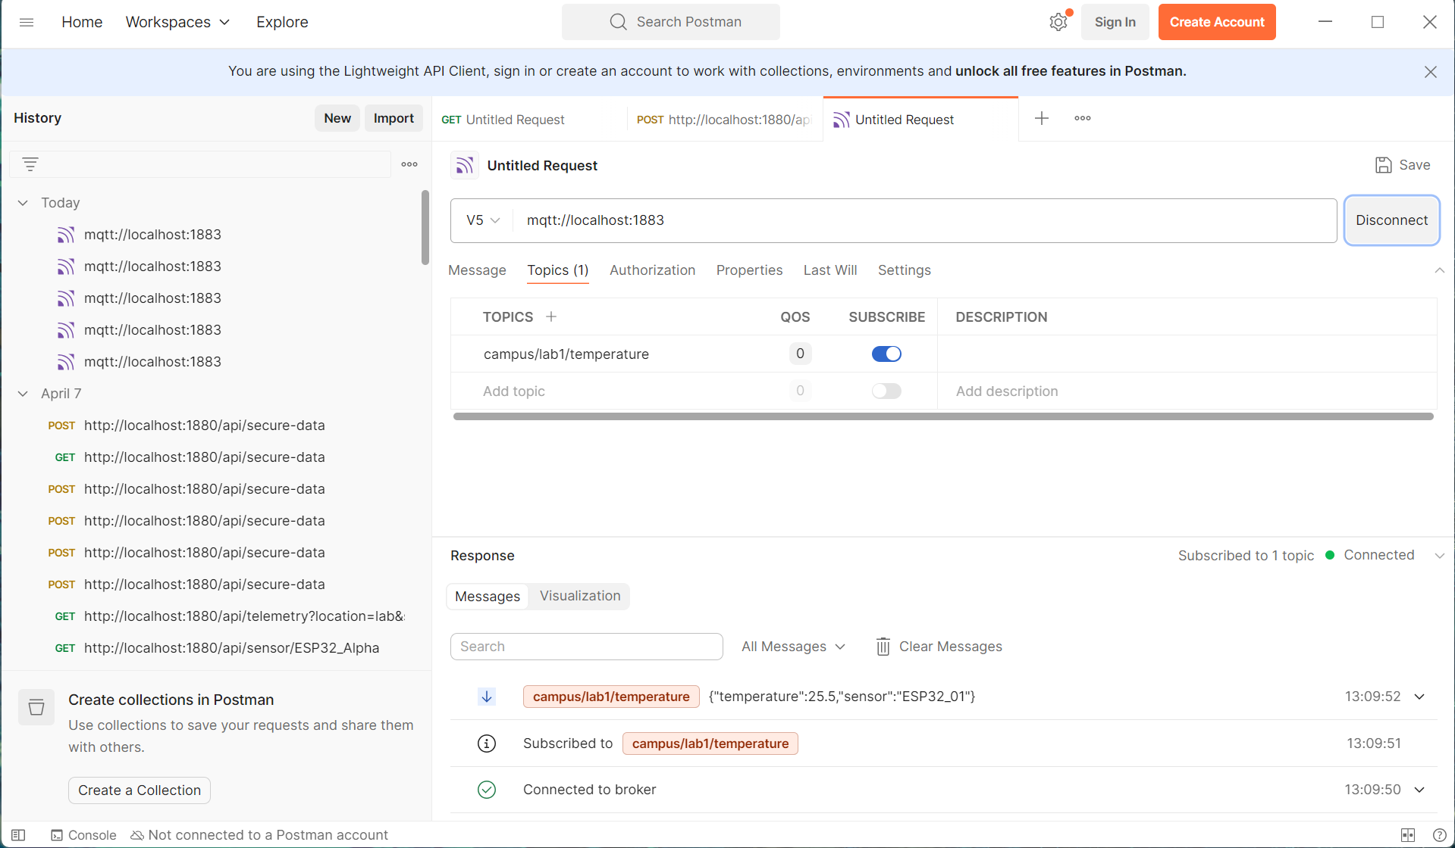
When subscribing to the topic campus/lab1/temperature, only messages published specifically to this exact topic were received in Postman. The data appeared in real-time at approximately 5-second intervals, matching the configured inject rate in Node-RED.

When subscribe to campus/#:
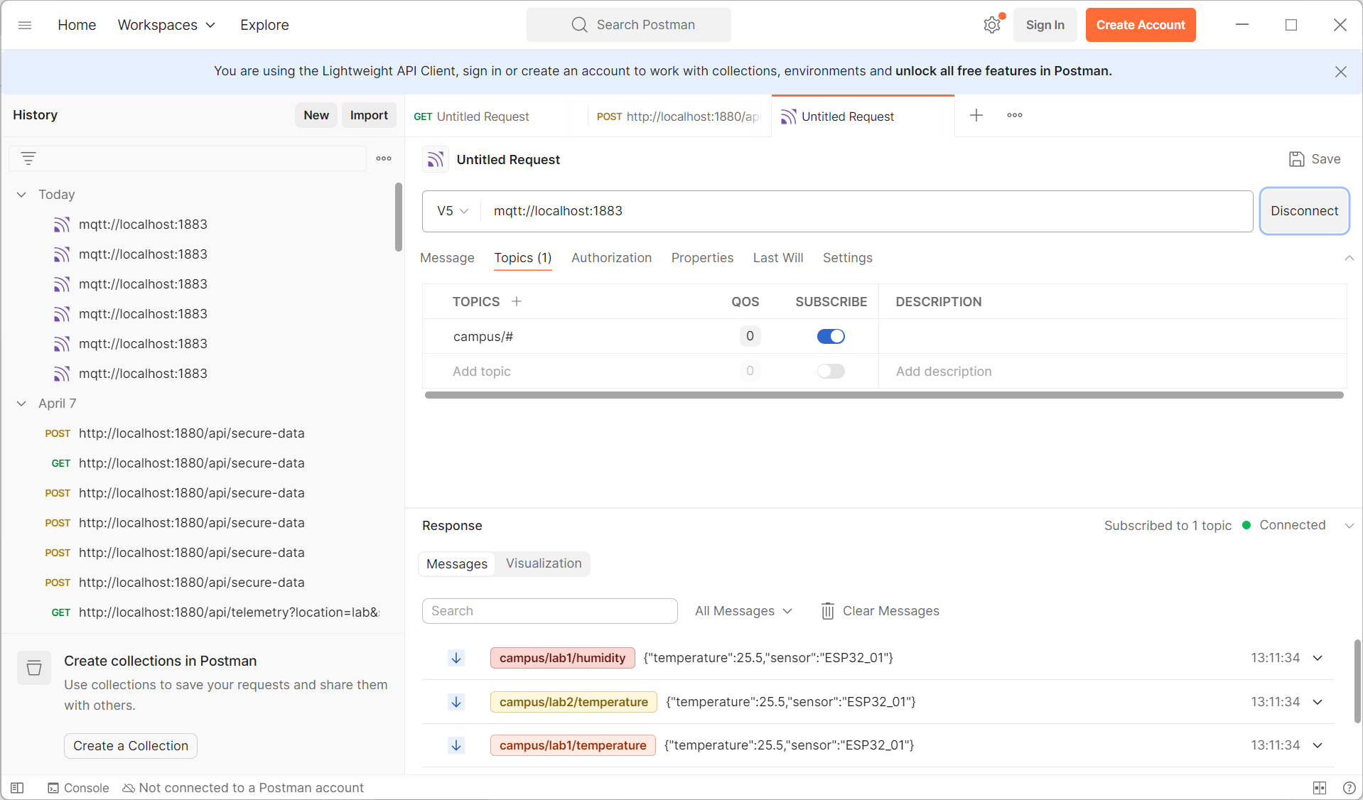
When subscribing to campus/#, Postman received messages from all topics under the campus hierarchy. This included campus/lab1/temperature, campus/lab2/temperature and campus/lab1/humidity. The message stream showed a mix of different payloads arriving from multiple sources, all interleaved in real-time. This demonstrates that the # wildcard matches any number of topic levels.
When subscribe to campus/+/temperature:
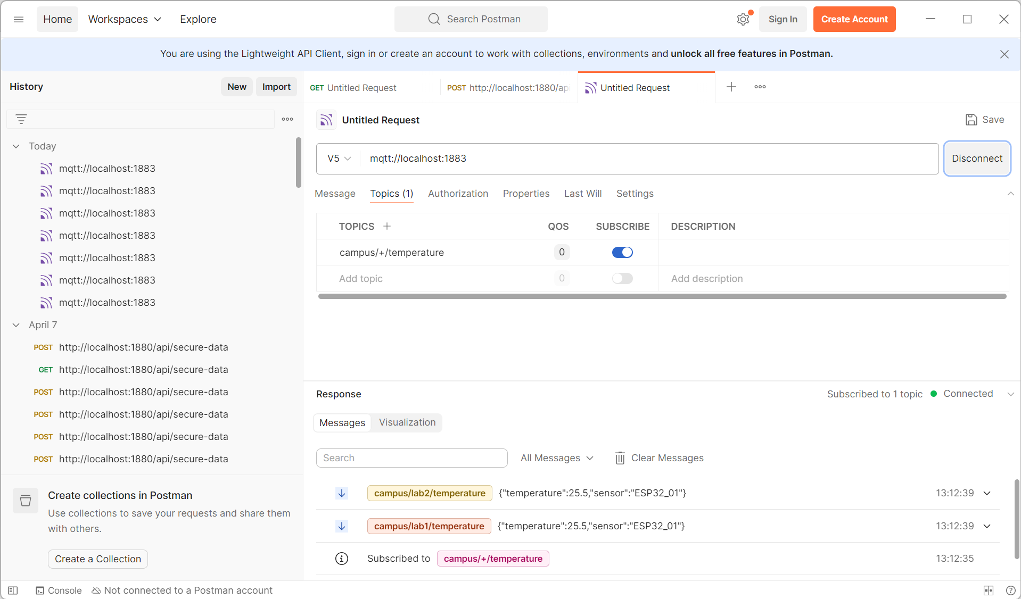
When subscribing to campus/+/temperature, only temperature data from different labs was received. Specifically are messages from campus/lab1/temperature and messages from campus/lab2/temperature. This indicates that the + wildcard matches exactly one level in the topic hierarchy, allowing selective filtering of topics. In this case, it filtered all temperature-related data across multiple labs while excluding other data types such as humidity.
Question 1: The Role of the Broker
The MQTT broker, such as EMQX, functions as a central intermediary that facilitates communication between clients in a publish/subscribe architecture. Instead of devices communicating directly with each other as in HTTP-based systems, all messages are sent to the broker, which then distributes them to the appropriate subscribers based on predefined topics. This design decouples the communication process, allowing publishers and subscribers to operate independently without needing knowledge of each other’s existence.
Compared to the HTTP protocol used in the previous exercise, MQTT offers several advantages. HTTP follows a request-response model that requires a direct connection between client and server, whereas MQTT uses an event-driven model that enables real-time data delivery. Additionally, MQTT is lightweight and consumes less bandwidth, making it highly suitable for resource-constrained IoT devices. Its topic-based filtering system also ensures that clients receive only relevant data, improving efficiency and scalability.
Question 2: Publish vs. Subscribe
In the MQTT protocol, a publisher is a client that sends messages to a specific topic on the broker, while a subscriber is a client that listens to one or more topics and receives messages when they are published. The publisher does not need to know which clients are subscribing to its data, and the subscriber does not need to know the source of the data, as the broker manages all message routing.
A single IoT device can function as both a publisher and a subscriber simultaneously. For example, an ESP32-based smart home device may publish temperature sensor data to a topic while also subscribing to another topic to receive control commands, such as turning an air conditioning system on or off. This dual functionality enables devices to both send and receive information, supporting more interactive and intelligent systems.

Question 3: Client vs. Server
In an MQTT system, if a subscribing client such as Postman disconnects while a publishing client like Node-RED continues to send data, the default behavior is that the messages will not be stored by the broker and will therefore be lost. As a result, when the subscriber reconnects after a period of disconnection, it will not receive any of the messages that were published during that time.
However, MQTT provides mechanisms to handle such situations if configured appropriately. Features such as Quality of Service (QoS), persistent sessions, and retained messages allow the broker to store and deliver messages to clients that were temporarily offline. With these features enabled, the system can ensure more reliable message delivery and better support intermittent connectivity, which is common in IoT environments.

